Contents

Context 2

Creating users in Active Directory 2

Microsoft 365 user creation, outlook and testing 8

Network diagram 13

Table of the items required with their estimated price 15

# Context

StarTech Business College wants us to setup an office in Sydney CBD with 2 classrooms. The college will have an Admin Office, Receptionist area, a teacher’s room, a room for marketing director, a room for accountant and a room for the director. The client also wants us to setup a Server, create a domain controller, OUs, Departments, and users.

And based on the information, we need to plan then items that we will be needing to have a fully function business in terms of Technology.

The team members of the College are as follows with their roles:

Names Roles

|  |  |
| --- | --- |
| Ratan Khan | Director |
| Mehak Singh | Admin |
| Rabin Williams | Admin |
| Rina Smith | Receptionist |
| Amit Sharma | Teachers |
| Karan Patel | Teachers |
| Mohan Jung | Marketing |
| Ruby Rana | Accountant |

# Creating users in Active Directory

First, looked for the available domain and names and decided to use the name ‘StarTech.Institute’

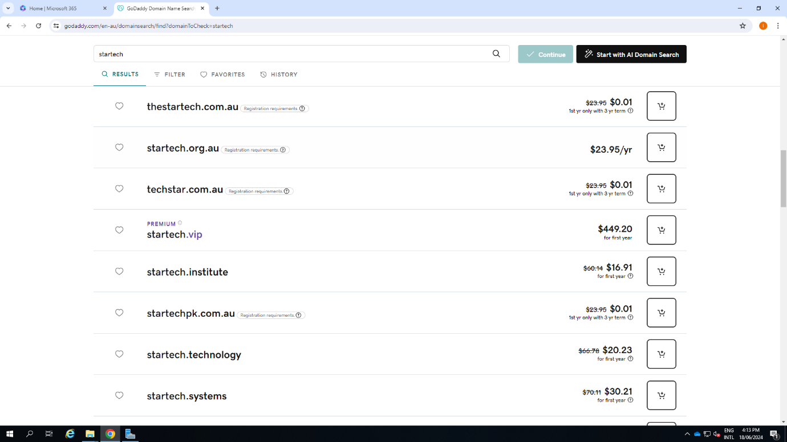

Created the marketing user ‘Mohan Jung’ and gave him roles and permissions

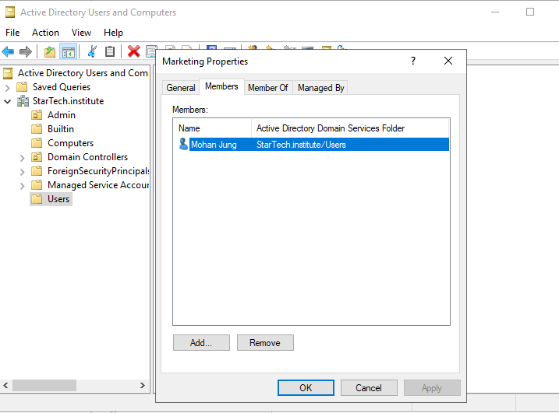

Created the users ‘Amit Sharma’ and ‘Karan Patel’ and added them to ‘Teachers’ group

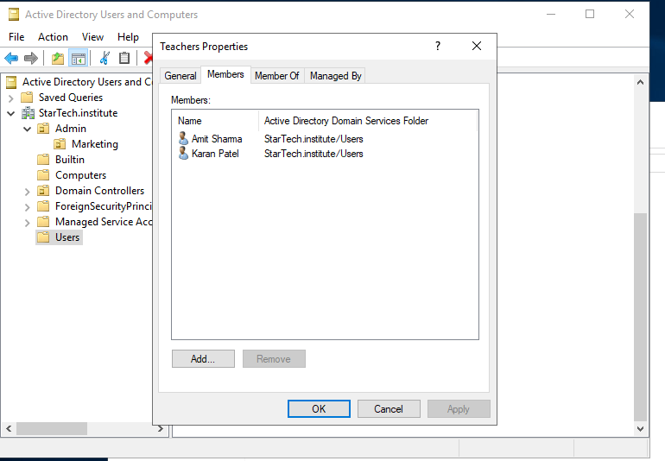

Created user ‘Rina Smith’ and gave her the role ‘receptionist’

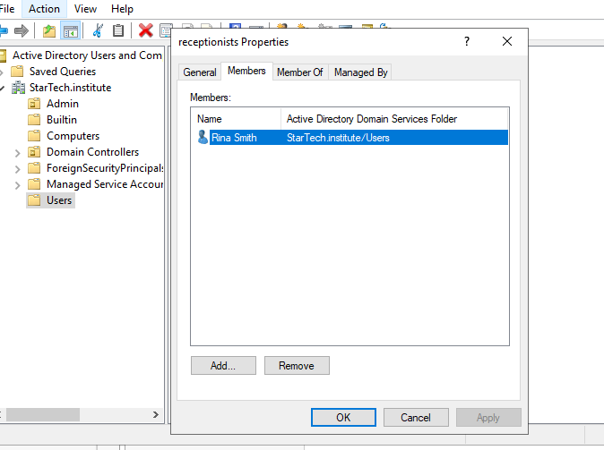

Created director ‘Ratan Khan’ and gave him permissions and access to everything

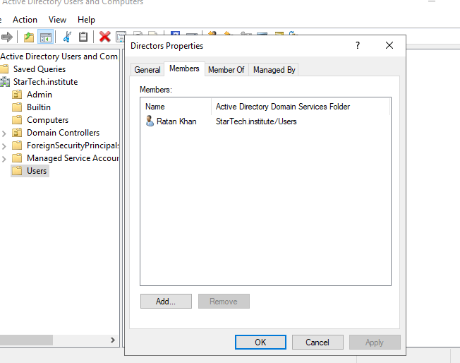

Created user ‘Ruby Rana’ with Accountant role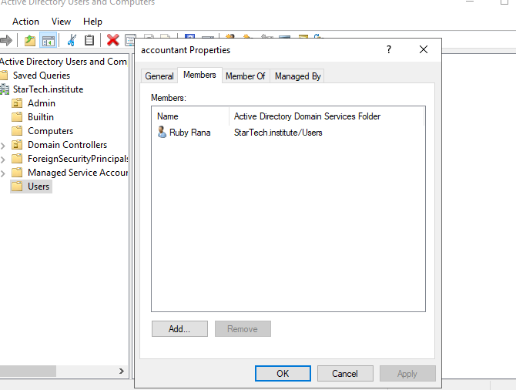

Added PC1 in the domain ‘StarTech.Institiute’

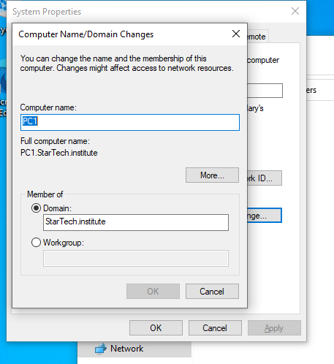

Created a document to check if the users can access the files in the server according to their access permission

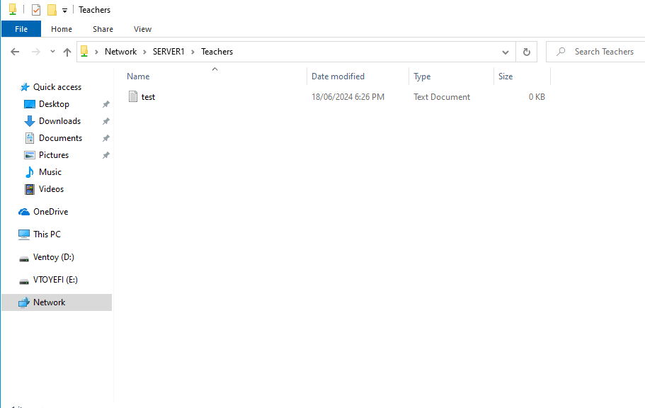

Gave file access to the group ‘Teachers’ in the server

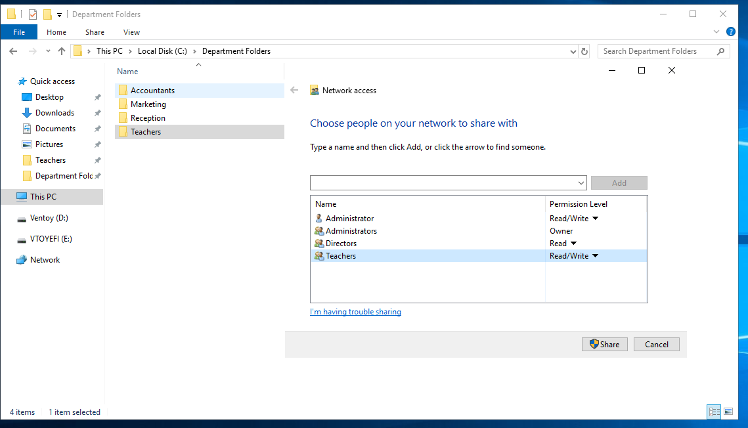

# Microsoft 365 user creation, outlook and testing

Added users

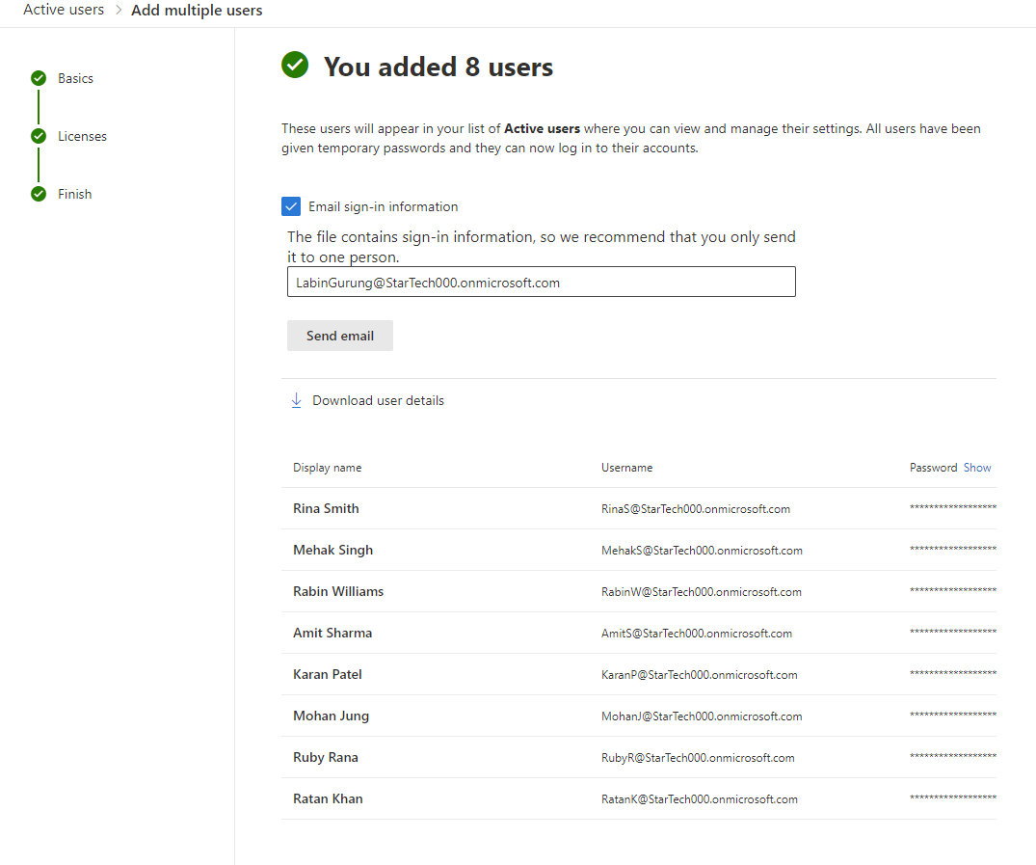

Gave Global admin permissions to selected users

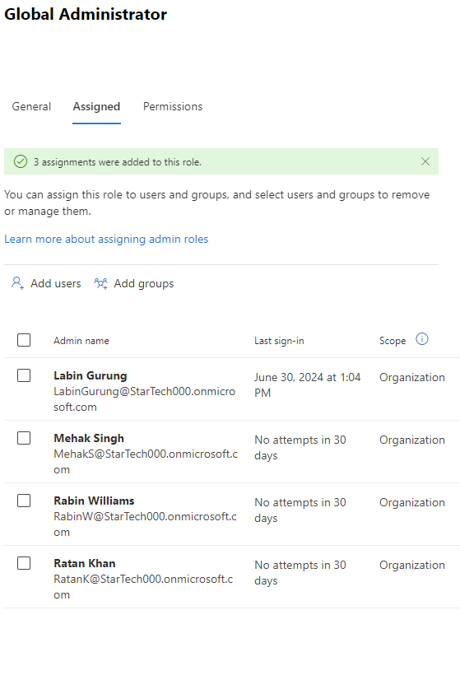

Created admin and teacher groups and added members

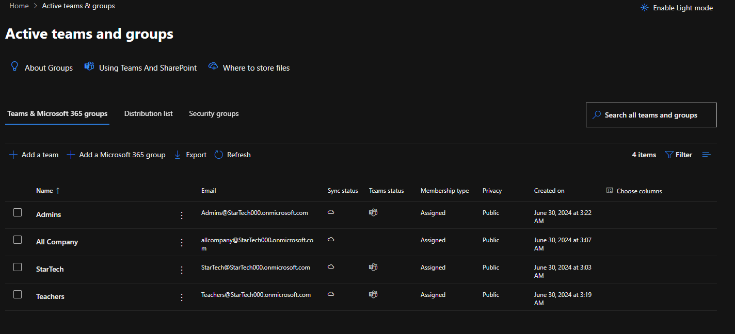

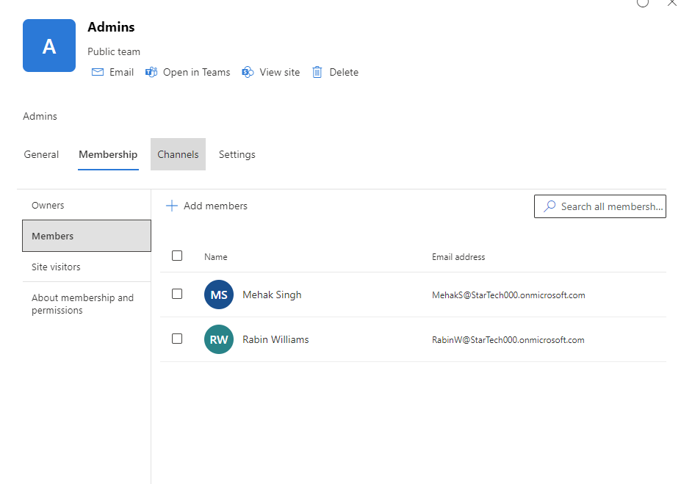

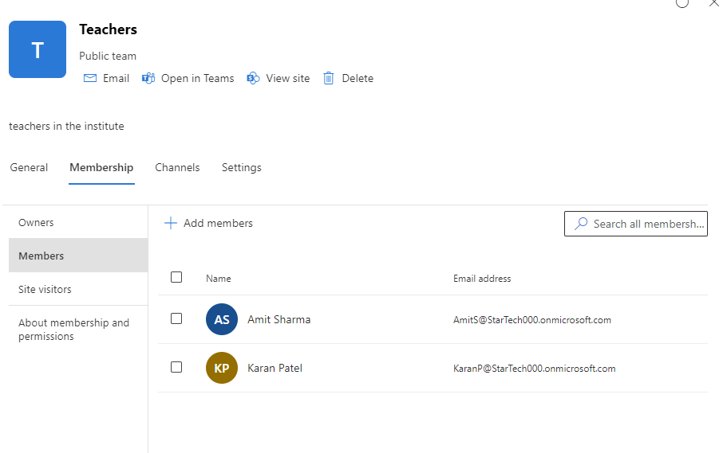

Created distribution list 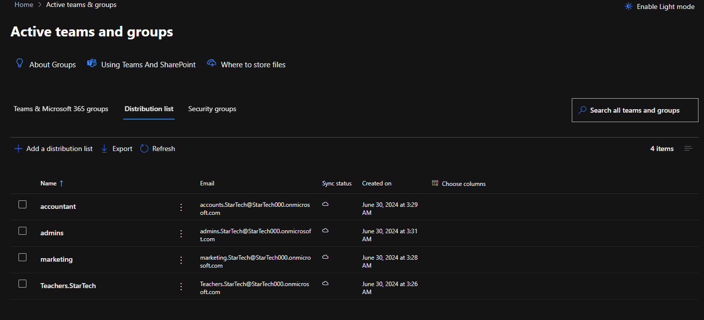

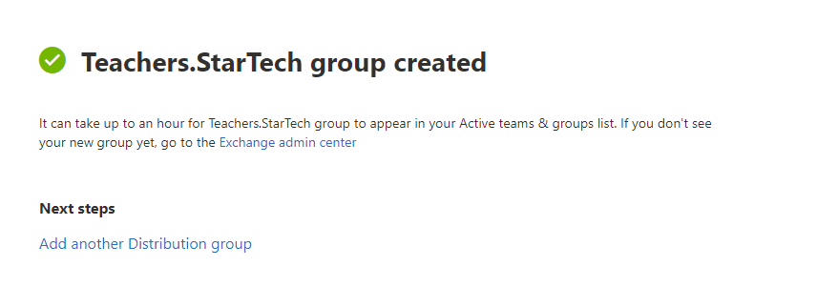

Testing distribution list as the user ‘Amit Sharma’ in Outlook

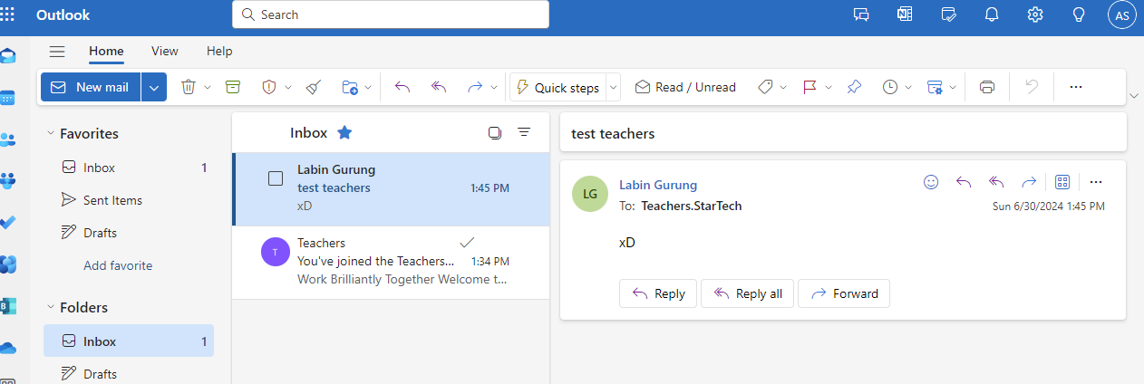

Created Shared Mailbox and tested

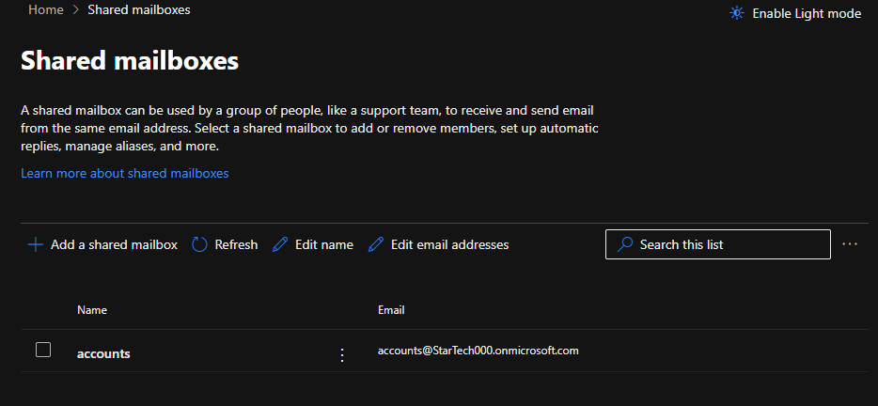

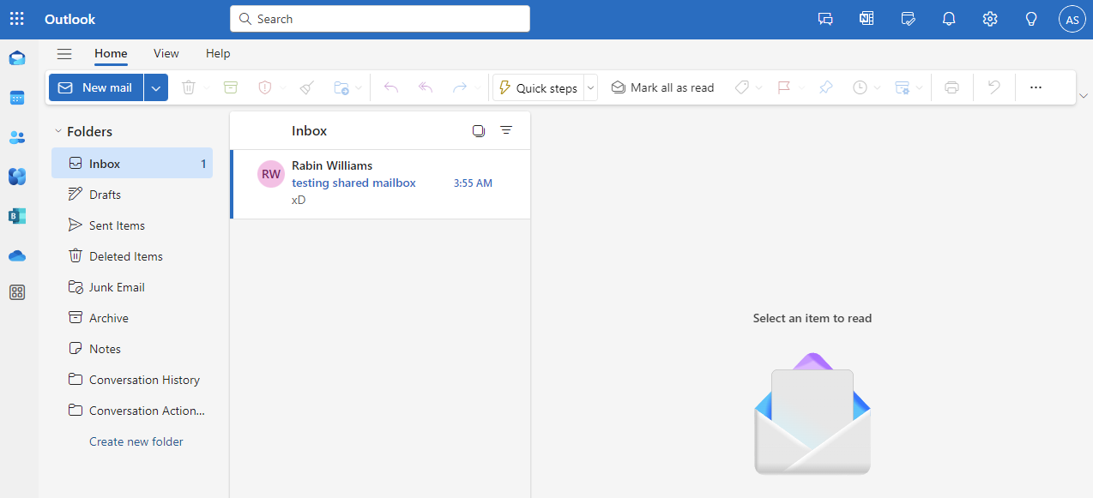

# Network diagram

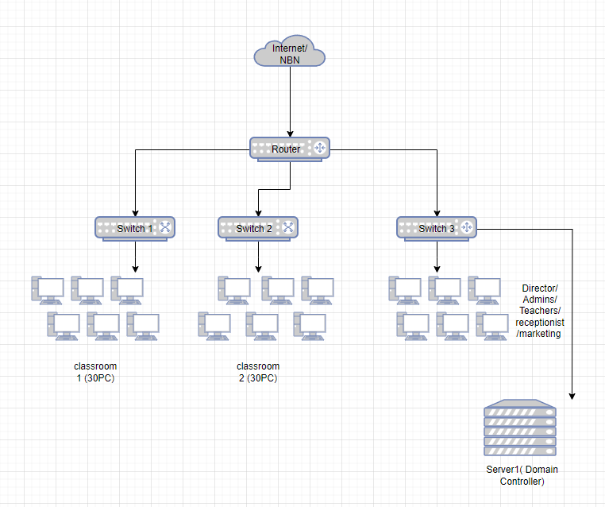

# Table of the items required with their estimated price

|  |  |  |  |
| --- | --- | --- | --- |
| Items Required | Provider / Supplier /Brand /model | Description/ comments | Cost |
| Internet | NBN  / Optus | Great plan for business,  Ultra WiFi Booster ( Gen 2), WiFi secure powered by McAfee | $139 per month ($0 startup fee) |
| PC*68 | Dell OptiPlex 3050 SFF Desktop PC  eBay/ refurbished | i5 7500 8GB RAM 128GB SSD Win 11 Pro | 149*68=$10132 |
| Monitor*70 | Dell U2419H 24" MONITOR / Kogan | Brand: Dell  Screen Size: 23.8 in  Maximum Resolution: 1920 × 1080  Model: U2419H  Features: Display +POWER CABLES, | 149*70=$10132 |
| Router | TP-Link AX10 Archer Wi-Fi 6 Router / JB HiFi | Data speed (Mbps)-1500  Frequency band-Dual Band (2.4/5.0GHz)  Beamforming  Ethernet / LAN ports-5  Wireless encryption-WPA, WPA2, WPA3 | $109 |
| Mouse*68 | Logitech M90 Optical Wired Mouse/ JB HiFi | Full-Size Comfort,  Ambidextrous Design  High-Definition Optical Tracking  Simple To Set Up and Use  USB Powered | 11*68=$748 |
| Keyboard*68 | Keji Slimline Wired Keyboard / officeworks | 435.4W x 138.6D x 20.88H mm  Compatibility- Windows  Device Connection-Wired | 7*68=$476 |
| Server Rack | Standing server rack cabinet / amazon | 42RU 800mm Deep x 800mm Wide Free 19" 19 Inch | $1156 |
| Server | Dell PowerEdge R730 2x Intel Xeon E5-2699v3 18C, 256GB RAM, 3x 100GB SSD, 8Gb FC  / kogan | 2x Intel Xeon E5-2699 v3 2.3GHz 18 Cores/ 36 Threads, 3.6GHz Boost - 72 Threads total  256GB Memory 2133MHz  3x 100Gb SATA SSD  iDRAC Enterprise  PERC H730P Mini RAID Controller  4 Port Intel Gigabit Ethernet  2 Port Intel Gigabit Ethernet  1x QLogic QLE2562 8Gb 2 Port Fibre Channel Adapter  2x 750w PSU | $800 |
| Projector*2 | Blaupunkt 1080p Projector White / Officeworks | 1920 x 1080 resolution  supports both 4:3 full screen and 16:9 widescreen aspect ratios  Remote Control  200 lumens brightness  1000 mm min screen distance | 197*2=$394 |
| Projector screen*2 | Standard Auto-lock Manual Projector Screen 90"/ officeworks | screen has an image diagonal size of 90"  wall-mountable | 114*2=$288 |
| Printer*2 | Brother HL-L2350DW Mono Laser Printer  / Brother | Compact Monochrome Laser Printer with automatic 2-sided printing and wireless connectivity  Print Speed- Up to 30 ppm | 189*2=$378 |
| ID card Printer | Badgy 100 Plastic Card Printer  /officeworks | simple and easy  high quality PVC material  compatible with both Mac and PC | $1000 |
| Printer (receptionist) | Brother HL-L3240CDW Compact Colour Laser Printer | print speed of 26 pages per minute  supports various wireless connectivity  allows for automatic duplexing | $399 |
| Switch * 3 | 48 PORT SWITCH HUB TP-LINK | 48-port 10/100M Switch, 48 10/100M RJ45 ports, 1U 19-inch rack-mountable steel case | 247*3= $741 |
| CC Tv Cameras | H800 - 4K 8 Channel 5 Cameras PoE Security System, Human & Vehicle Detection, Built-In Microphone & SD Card Slot, Color & IR Night Vision, RTSP Supported  /Annke | I91DL Camera  PoE Security System  RTSP supported  Color & IR Night Vision | $789 |
| Patch panel * 4 | 1RU 60x CAT3 PORTS 19” PATCH PANEL  /wagner | RJ45, 60 ports, 1 RU, 8P4C connectors | 88*4= $352 |
| Office 365 | Microsoft 365 Business Premium | Advanced identity and access management  Enhanced cyberthreat protection against viruses and phishing attacks  Copilot for Microsoft 365, available as an add-on3 | $32.90 |
| Camera | Logitech Brio 500 Webcam, Graphite | Resolutions-1080p/30fps (1920x1080pixels)  720p/60fps (1280x720 pixels)  USB-C plug-and-play | $160 |
| Ethernet Cable* 10 | RJ45 CAT6 Ethernet Network LAN Patch Cable 1000Mbps  /Amazon | 30M RJ45 CAT6 Ethernet LAN Network Cable 10/100/1000Mbps compatible  RJ45 connectors in both ends | 22 * 10 = $220 |
| Ethernet cable reel | CAT6 Ethernet Cable Reel Box UTP LAN Cable w/ Solid Conductor | 305m Blue | 305m  CAT6 Ethernet Cable  UTP LAN w/Solid Conductor | $201 |
| Consultation Fee |  |  | $5000 |

Total Estimated Cost= $34000